FitLife Gym Website Project Report

1. ACKNOWLEDGEMENT
I would like to express my sincere gratitude to everyone who supported me in completing this project. Special thanks to my mentor and peers for guidance, and online resources that helped in learning web development concepts and implementing them effectively.

2. CONTENTS
Sr. No | Title | Page No
1 | Acknowledgement | 1
2 | Contents | 2
3 | List of Figures | 3
4 | Abstract | 4
5 | Introduction | 5
6 | Language Usages | 6
7 | Platform Usages | 7
8 | Working | 8
9 | Coding | 15
10 | Screenshots/Mockups | 35
11 | Conclusion | 50

3. LIST OF FIGURES
Fig. No | Description | Page No
1 | Home Page Layout | 35
2 | Services Section | 36
3 | Pricing Plans Section | 37
4 | Contact Form Section | 38
5 | Scroll Animation Example | 39

4. ABSTRACT
This project involves the development of a gym landing website named FitLife Gym using HTML, CSS, and JavaScript. The website is designed to provide information about gym services, pricing plans, and a contact form for new users. Modern web design features such as scroll animations, smooth scrolling, responsive layouts, and interactive buttons are incorporated to enhance user experience.

5. INTRODUCTION
The purpose of this project is to design and develop a simple yet modern web interface for a gym business. The website allows users to learn about available services, select membership plans, and contact the gym easily. By using standard web technologies, this project demonstrates basic web development skills while creating a user-friendly interface.

6. LANGUAGE USAGES
- HTML5 – Structure and layout of the web pages.
- CSS3 – Styling, layout design, animations, and responsiveness.
- JavaScript – Interactivity, smooth scrolling, and form handling.

7. PLATFORM USAGES
- Local Development: Using web browsers like Chrome, Firefox, or Edge.
- Web Hosting Platforms: GitHub Pages, Netlify, or Vercel for online access.
- Operating Systems: Windows, MacOS, Linux.

8. WORKING
- The Home section introduces the gym with a hero image and a “Join Now” button.
- The Services section showcases the gym’s offerings with animated cards.
- The Pricing Plans section displays three membership plans. Clicking a plan scrolls the page to the Contact form and pre-fills the selected plan message.
- The Contact form allows users to submit their name, email, and message.
- The website is responsive, adapting to various screen sizes, and has smooth scroll animations to enhance user experience.

9. CODING
Note: Insert your HTML, CSS, and JS code here. Organize it as:
9.1 HTML (index.html)
<!DOCTYPE html>
<html lang="en">
<head>
<meta charset="UTF-8">
<meta name="viewport" content="width=device-width, initial-scale=1.0">
<title>FitLife Gym</title>
<link rel="stylesheet" href="style.css">
</head>
<body>

<header>
<nav class="navbar">
<h1>FitLife Gym</h1>
<ul>
<li><a href="#home">Home</a></li>
<li><a href="#services">Services</a></li>
<li><a href="#pricing">Pricing</a></li>
<li><a href="#contact">Contact</a></li>
</ul>
</nav>
</header>

<section id="home" class="hero">
<div class="hero-content">
<h2>Welcome to FitLife Gym</h2>
<p>Your journey to a healthier, stronger you starts here!</p>
<button id="joinBtn" class="btn">Join Now</button>
</div>
</section>

<section id="services">
<h2 class="scroll-animate">Our Services</h2>
<div class="cards">
<div class="card scroll-left">
<h3>Strength Training</h3>
<p>Build muscle and increase strength with our guided programs.</p>
</div>
<div class="card scroll-animate">
<h3>Cardio Workouts</h3>
<p>Burn calories and boost endurance with fun cardio sessions.</p>
</div>
<div class="card scroll-right">
<h3>Personal Training</h3>
<p>Get one-on-one coaching from certified trainers.</p>
</div>
</div>
</section>

<section id="pricing" class="scroll-animate">
<h2>Pricing Plans</h2>
<div class="cards pricing-cards">
<div class="card scroll-left">
<h3>Basic</h3>
<p class="price">$29/mo</p>
<ul>
<li>Access to gym equipment</li>
<li>1 group class per week</li>
<li>Locker room access</li>
</ul>
<button class="btn select-plan" data-plan="Basic">Select Plan</button>
</div>
<div class="card scroll-animate">
<h3>Standard</h3>
<p class="price">$49/mo</p>
<ul>
<li>All Basic features</li>
<li>3 group classes per week</li>
<li>Personal trainer 1 session/month</li>
</ul>
<button class="btn select-plan" data-plan="Standard">Select Plan</button>
</div>
<div class="card scroll-right">
<h3>Premium</h3>
<p class="price">$79/mo</p>
<ul>
<li>All Standard features</li>
<li>Unlimited classes</li>
<li>Weekly personal trainer session</li>
</ul>
<button class="btn select-plan" data-plan="Premium">Select Plan</button>
</div>
</div>
</section>

<section id="contact" class="scroll-animate">
<h2>Contact Us</h2>
<form id="contactForm">
<input type="text" id="name" placeholder="Your Name" required>
<input type="email" id="email" placeholder="Your Email" required>
<textarea id="message" placeholder="Message" required></textarea>
<button type="submit" class="btn">Send</button>
</form>
</section>

<footer>
<p>&copy; 2025 FitLife Gym. All rights reserved.</p>
</footer>

<script src="script.js"></script>
</body>
</html>

9.2 CSS (style.css)
/* Reset */
* {
margin: 0;
padding: 0;
box-sizing: border-box;
}

body {
font-family: 'Arial', sans-serif;
line-height: 1.6;
background-color: #f4f4f4;
color: #333;
scroll-behavior: smooth;
}

header {
position: sticky;
top: 0;
background-color: #222;
z-index: 100;
}

nav.navbar {
display: flex;
justify-content: space-between;
align-items: center;
padding: 15px 20px;
}

nav ul {
display: flex;
list-style: none;
}

nav ul li {
margin-left: 20px;
}

nav ul li a {
color: #fff;
text-decoration: none;
font-weight: bold;
transition: color 0.3s;
}

nav ul li a:hover {
color: #ff4b2b;
}

.hero {
height: 100vh;
display: flex;
align-items: center;
justify-content: center;
background: url('https://images.unsplash.com/photo-1554284126-6e9b9a2b203d?fit=crop&w=1350&q=80') no-repeat center center/cover;
color: white;
text-align: center;
}

.hero-content {
background-color: rgba(0,0,0,0.5);
padding: 40px;
border-radius: 10px;
animation: fadeIn 1.5s ease-in;
}

.btn {
padding: 12px 25px;
margin-top: 20px;
border: none;
background-color: #ff4b2b;
color: white;
font-size: 1rem;
cursor: pointer;
border-radius: 5px;
transition: transform 0.3s, background-color 0.3s;
}

.btn:hover {
background-color: #ff6b50;
transform: scale(1.05);
}

section {
padding: 80px 20px;
text-align: center;
}

.cards {
display: flex;
justify-content: center;
gap: 20px;
flex-wrap: wrap;
margin-top: 30px;
}

.card {
background-color: white;
padding: 25px;
width: 250px;
border-radius: 10px;
box-shadow: 0 5px 15px rgba(0,0,0,0.2);
transition: transform 0.4s, box-shadow 0.4s;
}

.card:hover {
transform: translateY(-10px);
box-shadow: 0 10px 20px rgba(0,0,0,0.3);
}

form {
max-width: 450px;
margin: 0 auto;
display: flex;
flex-direction: column;
gap: 15px;
}

input, textarea {
padding: 12px;
border: 1px solid #ccc;
border-radius: 5px;
resize: none;
}

footer {
background-color: #222;
color: white;
text-align: center;
padding: 20px;
}

/* Pricing cards */
.pricing-cards .card {
width: 280px;
}

.pricing-cards .price {
font-size: 2rem;
color: #ff4b2b;
margin: 15px 0;
}

.pricing-cards ul {
list-style: none;
margin: 15px 0;
padding: 0;
}

.pricing-cards ul li {
padding: 8px 0;
border-bottom: 1px solid #ddd;
}

/* Scroll animations */
.scroll-animate {
opacity: 0;
transform: translateY(30px);
transition: all 0.8s ease-out;
}

.scroll-animate.show {
opacity: 1;
transform: translateY(0);
}

.scroll-left {
transform: translateX(-50px);
}

.scroll-left.show {
transform: translateX(0);
}

.scroll-right {
transform: translateX(50px);
}

.scroll-right.show {
transform: translateX(0);
}

/* Highlight effect for Contact */
#contact.highlight {
background-color: #fffbf0;
transition: background-color 0.5s;
}

/* Responsive */
@media(max-width: 768px) {
.cards, .pricing-cards {
flex-direction: column;
align-items: center;
}

nav ul {
flex-direction: column;
gap: 10px;
}
}

9.3 JavaScript (script.js)
// Smooth scroll to Contact section when "Join Now" is clicked
document.getElementById('joinBtn').addEventListener('click', function() {
const contactSection = document.getElementById('contact');
contactSection.scrollIntoView({ behavior: 'smooth' });
contactSection.classList.add('highlight');
setTimeout(() => contactSection.classList.remove('highlight'), 1500);

// Pre-fill message
document.getElementById('message').value = "I want to join FitLife Gym!";
});

// Contact form submit
document.getElementById('contactForm').addEventListener('submit', function(e) {
e.preventDefault();
alert('Message sent successfully!');
this.reset();
});

// Pricing plan selection
document.querySelectorAll('.select-plan').forEach(button => {
button.addEventListener('click', function() {
const plan = this.dataset.plan;
const contactSection = document.getElementById('contact');
contactSection.scrollIntoView({ behavior: 'smooth' });
contactSection.classList.add('highlight');
setTimeout(() => contactSection.classList.remove('highlight'), 1500);

// Pre-fill message with selected plan
document.getElementById('message').value = `I want to join the ${plan} plan!`;
});
});

// Scroll animations
const scrollElements = document.querySelectorAll('.scroll-animate, .scroll-left, .scroll-right');

const observer = new IntersectionObserver(entries => {
entries.forEach(entry => {
if(entry.isIntersecting){
entry.target.classList.add('show');
}
});
}, { threshold: 0.2 });

scrollElements.forEach(el => observer.observe(el));

10. SCREENSHOTS / MOCKUPS
- Figure 1: Home Page
- 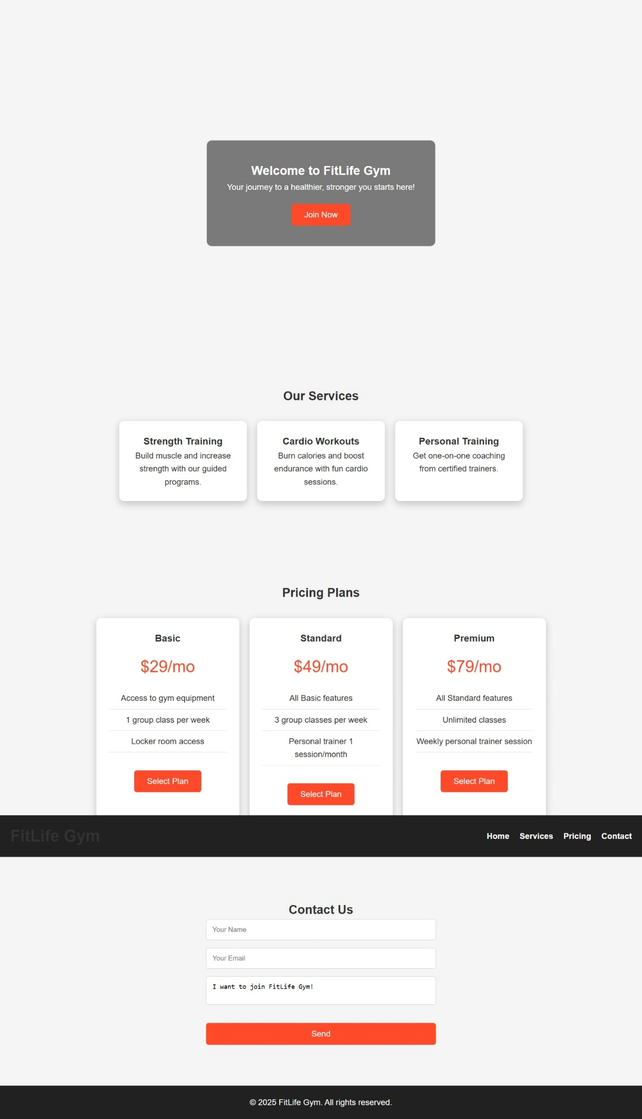
- Figure 2: Services
- 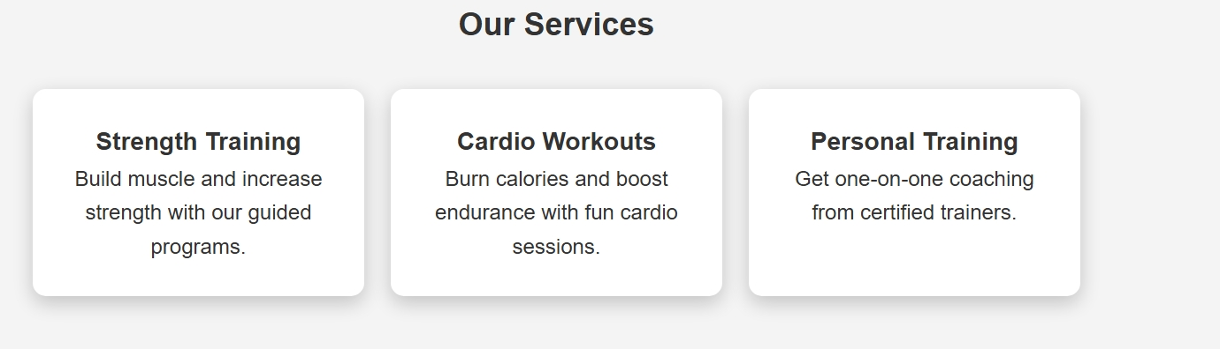
- Figure 3: Pricing Plans Section
- 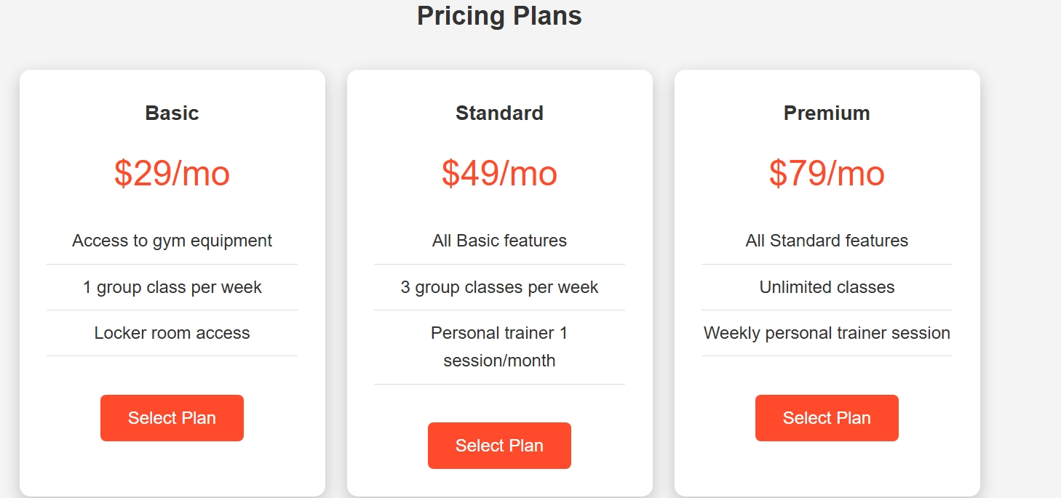
- Figure 4: Contact Form Section
- 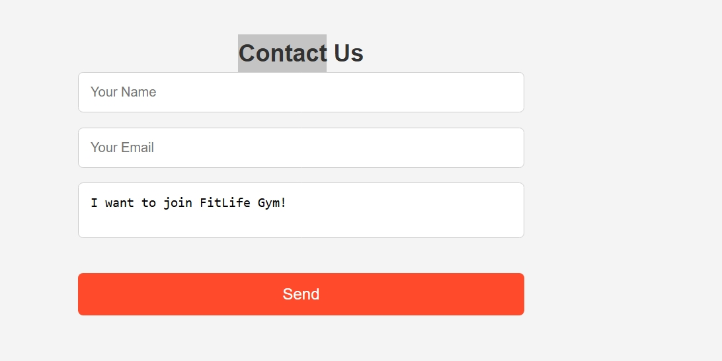
- Figure 5: Scroll Animation Example
- 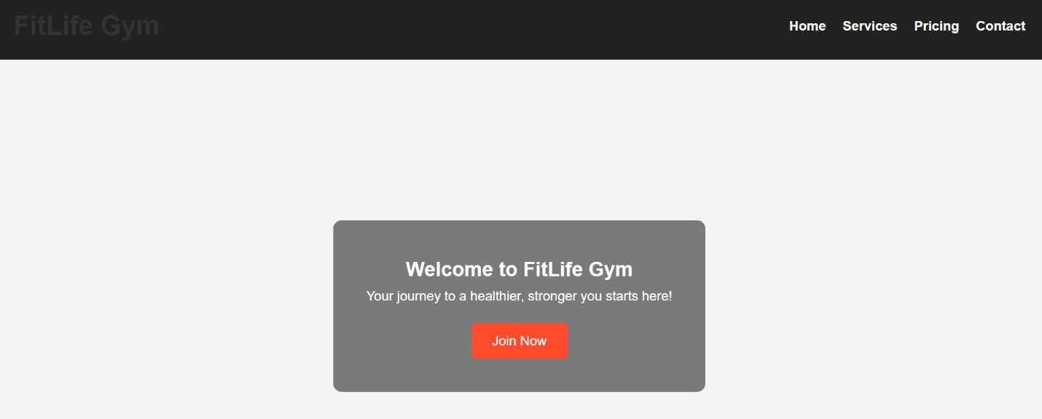

11. CONCLUSION
The FitLife Gym website demonstrates the development of a responsive, interactive, and modern web application using HTML, CSS, and JavaScript. It provides a complete front-end solution for presenting gym services, pricing plans, and collecting user inquiries. The project enhances web development skills and can be extended in the future with backend integration, database storage, or more advanced UI features.

